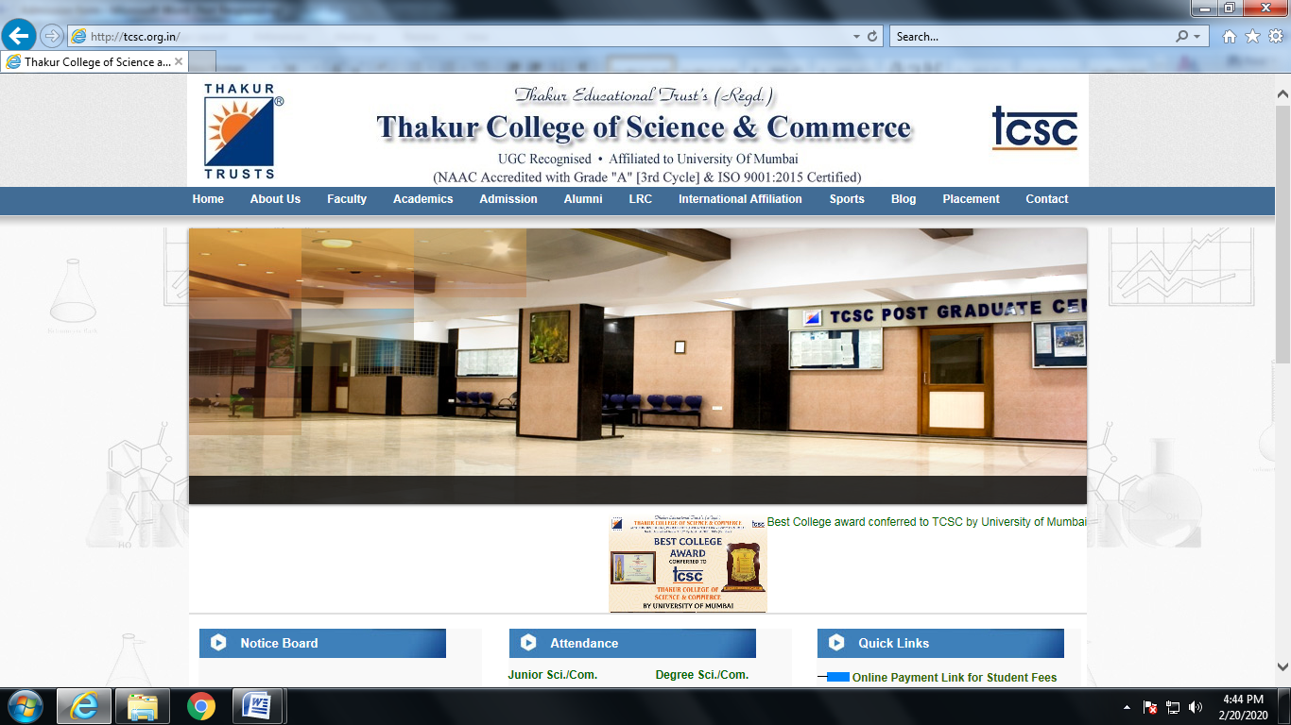

**Defence and Govt Career Training Institute**

**Admission Form**

1. **Name of the Applicant : _________________________________________________**

**Affix Passport Size Photo graph**

1. **Training Required for : __________________________________________________**

**(NDA/ CDS/ AFCAT/ INET/ Soldiers/Sailors/Airman /MNS/CAPF/CGL/CHSL/**

**Govt.ervices/)**

1. **Parents Name: _________________________Parents Contact No: ______________**

**4.** **Date of Birth: _____ / _____ / ______ 4. Gender : Male / Female________________**

1. **Address of Correspondence: ______________________________________________**

**________________________________________ City : _________________________**

**Pin Code: ______________ Mobile : _______________Email ______________________**

* 1. **Academic and Professional Qualifications:**

|  |  |  |  |  |  |  |
| --- | --- | --- | --- | --- | --- | --- |
| **Level** | **Name of** | **Specialization/** | **Institute / School** | **University /** | **Year of** | **Marks** |
|  | **Degree** | **Branch/Subjects** | **College** | **Board** | **Passing** | **in%** |
|  |  |  |  |  |  |  |
| **Std X** |  |  |  |  |  |  |
|  |  |  |  |  |  |  |
| **Std XII** |  |  |  |  |  |  |
|  |  |  |  |  |  |  |
| **Dip. Engg.** |  |  |  |  |  |  |
|  |  |  |  |  |  |  |
| **Graduation** |  |  |  |  |  |  |
|  |  |  |  |  |  |  |
| **PG** |  |  |  |  |  |  |
|  |  |  |  |  |  |  |

I hereby declare that the information given above is true to the best of my knowledge. I shall abide by all the rules and regulations as prescribed by Institute

|  |  |  |  |  |  |  |  |
| --- | --- | --- | --- | --- | --- | --- | --- |
| **Place :** _____________________ | | ___________________ | | | | ___________________________ | |
| **Date :** _____ / _____ / ________ | | **(Parent’s Signature)** | | | | **(Applicant’s Signature)** | |
| **______________________________________________________________________________________** | | | | | | | |
| **(For Office use only)** | | | | | |  | |
|  | |  | **Details of fees:** | | | |  | |
|  |  | | | |  | | |
| **Date:_________ Amount:____________ Cheque/DD No/Txn: _________Bank:_____________________** | | | | | | | |
| **Class Admitted: _____________** | |  | | **Authorized Signatory: _____________________** | | | | |